
Compiler Construction
Lab 4
Name: Fatima Zahra
Sap Id: 55551
Submitted To: Ma’am Hasnat

Riphah International University of Islamabad
Task 1:
#include <iostream>
using namespace std;
struct symbol {
string name;
string type;
string value;
int memory_size;
};
int main() {
symbol table[10];
int n;
cout << "How many variables do you want to enter? ";
cin >> n;
for(int i = 0; i < n; i++) {
cout << "\nEnter data type: ";
cin >> table[i].type;
cout << "Enter variable name: ";
cin >> table[i].name;
cout << "Enter value: ";
cin >> table[i].value;

// Assign memory size
if(table[i].type == "int")
table[i].memory_size = 4;
else if(table[i].type == "float")
table[i].memory_size = 4;
else if(table[i].type == "char")
table[i].memory_size = 1;
else
table[i].memory_size = 0;
}
cout << "\n--- Symbol Table ---\n";
cout << "Name\tType\tValue\tMemory Size\n";
for(int i = 0; i < n; i++) {
cout << table[i].name << "\t"
<< table[i].type << "\t"
<< table[i].value << "\t"
<< table[i].memory_size << " bytes\n";
}
return 0;
}
Output:
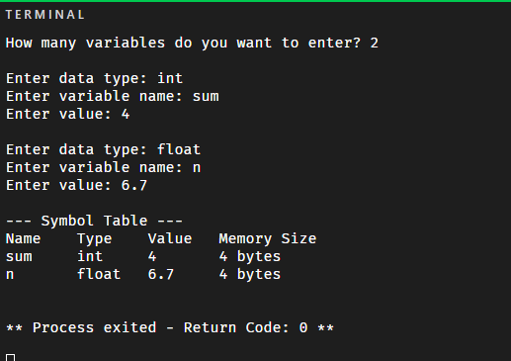

Task 2:
#include <iostream>
using namespace std;
struct Symbol {
string name;
string type;
int address;
};
int main() {
int n;
cout << "Enter number of identifiers: ";
cin >> n;
for (int i = 0; i < n; i++) {
cout << "\nEnter details for identifier " << i + 1 << endl;
cout << "Name: ";
cin >> table[i].name;
cout << "Type: ";
cin >> table[i].type;
cout << "Address: ";
cin >> table[i].address;
}
string searchName;
cout << "\nEnter identifier name to search: ";
cin >> searchName;
bool found = false;
for (int i = 0; i < n; i++) {
if (table[i].name == searchName) {
cout << "\nIdentifier Found!\n";
cout << "Name: " << table[i].name << endl;
cout << "Type: " << table[i].type << endl;
cout << "Address: " << table[i].address << endl;
found = true;
break;
}
}
if(!found) {
cout << "\nIdentifier not found.\n";
}
return 0;
}
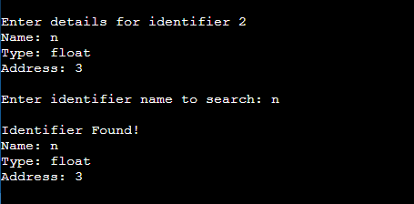

Task 3:
#include <iostream>
using namespace std;

struct Symbol {
string name;
string type;
int address;
};

int main() {
Symbol table[100];
int n;
int count = 0;
cout << "Enter number of identifiers to insert: ";
cin >> n;
for (int i = 0; i < n; i++) {
string name, type;
int address;
bool duplicate = false;
cout << "\nEnter identifier name: ";
cin >> name;
// Check for duplicate
for (int j = 0; j < count; j++) {
if (table[j].name == name) {
duplicate = true;
break;
}
}
if (duplicate) {
cout << "Error: Duplicate identifier! Insertion not allowed.\n";
} else {
cout << "Enter type: ";
cin >> type;
cout << "Enter value: ";
cin >> address;
table[count].name = name;
table[count].type = type;
table[count].address = address;
count++;
cout << "Identifier inserted successfully.\n";
}
}
// Display final symbol table
cout << "\nFinal Symbol Table :\n";
for (int i = 0; i < count; i++) {
cout << "\nName: " << table[i].name;
cout << "\nType: " << table[i].type;
cout << "\nvalue: " << table[i].address << endl;
}
return 0;
}
